**DEVELOPMENT AND TOURISM**

If you are looking for the purest of Dravidian culture, Chidambaram is the best place to go to in South India. Chidambaram being one of the most visited towns in Southern India, tourism has developed significantly, and it still does today. It  is main sacred destination for Shaivites (Followers of Shiva) and Vaishnavites (followers of Vishnu). Tertiary sector involving tourism is the major occupation in Chidambaram.

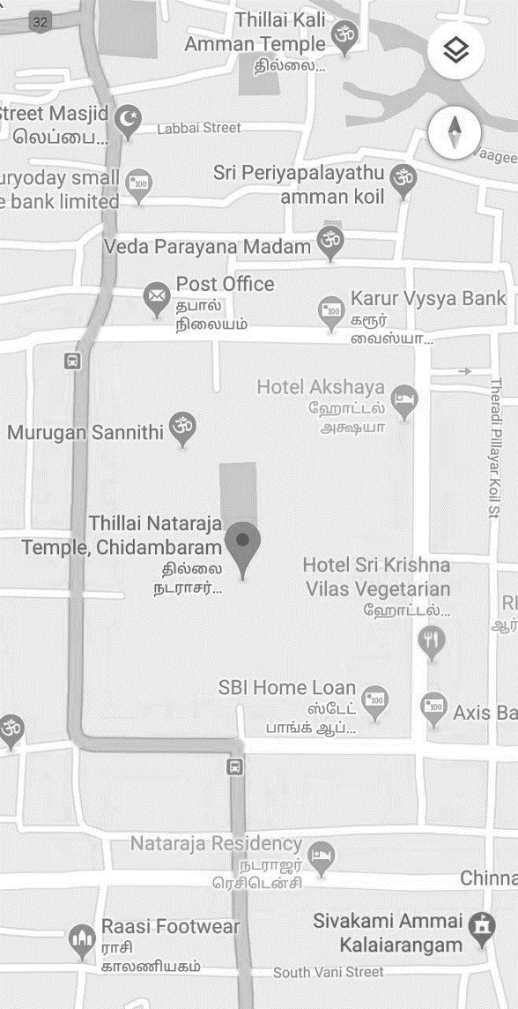The Department of Tourism started a Tourist office at Chidambaram in 1979. It is located at Railway Feeder Road Chidambaram very near to Railway Station and Bus stand. At present, the Tourist office is manned by the Tourist officer along with one Assistant Tourist officer, one Junior Assistant, one Typist and Two Office Assistant. The Tourist officers have large areas under their jurisdiction. The main role of the tourist office is to promote the Tourism activities such as information about Tamil Nadu Tourist Places and give free District wise Tourism folders to the tourists, both domestic and foreigners.

There are around 3 lakh annual tourist arrivals in Chidambaram. It has adequate road connections and one national highway passes through the town. Roads are a major means of transportation. Tourism forms the economic base of Chidambaram centred around the natraja temple.

Talking about transportation which is the primary factor in tourism there are Minibus services operated by private companies cater to the local transport needs. The main bus stand is in the heart of the town. [Chidambaram railway station](https://en.wikipedia.org/wiki/Chidambaram_railway_station) is located in the rail head and the Pondicherry Airport is a nearest airport located around 66 kilometres away from Chidambaram.

It is said that carrying out dances in front of the Nataraja is bliss. Tons of folk-dance performers get allured to Chidambaram during the festival of Natyanjali. The Natyanjali Festival in Chidambaram is a famous tourist festival celebrated every year. Apart from religious importance, the place offers its visitors an excellent opportunity of sightseeing and shopping in and around the city. Chidambaram is a town of natural beauty, Hinduism and festivals. So, the best time to visit this tourist destination is when nature is at its peak and when festivals are celebrated. Chidambaram offers a mixture of nature and spirituality.

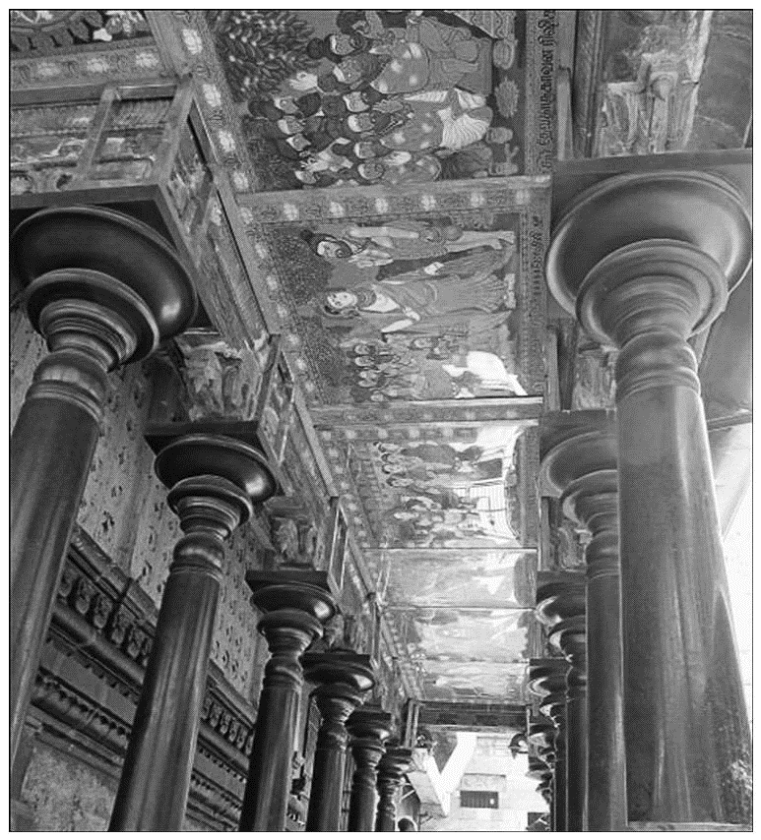There is Mangrove forest around this town and it also offers waterways, exotic birds, seafood and temples with outstanding architecture to be relished by the tourists. This amalgamation of religion and nature makes this town a major tourist attraction for visitors around India and also from the world. This temple holds inscriptions of empires reigning for almost 5 centuries. Apart from a rich history, Chidambaram's scenic beauty surpasses numerous places in South India and adds to the growth of tourism here. It is a perfect place for nature lovers as one could get lost amidst the beauty of the forests and will be astonished by the backwaters of Pichavaram. For bird lovers too, Chidambaram shall not disappoint as migratory birds, in significant numbers, come to the Pichavaram Mangrove Forest. There are no tourist destinations close to Chidambaram and hence, staying in this town itself, is recommended.

During the empire of Pallava and Chola kings, the temple had gone through scores of renovations. Famous for its huge walls, artistic carvings and appealing inscriptions, it is amongst the few temples where Lord Shiva is portrayed in the deity form instead of the common 'Lingam' (phallus form of Shiva representation). In 2015, renovation of paintings was done with natural colours. Drawing the sacred forms of deities and temple depictions were entrusted to the famous Spiritual Artist Padmavasan.

The temple town of Chidambaram is home to the Annamalai University, and it has several modern lodging facilities. The Tamilnadu Tourist Development Corporation operates one of its hotels at Chidambaram. Chidambaram is on the Chennai Tiruchirappalli Main line, between Villuppuram and Thanjavur. It is well connected with Chennai by a host of train and bus services. By road it is only 235 kilometers South of Chennai. Thanjavur is only about 100 kilometers away from Chidambaram. Chidambaram is literally the Northern gateway to the temple trough of Tamilnadu - the Thanjavur - Tiruvarur - Nagapattinam districts featuring hundreds and hundreds of ancient temples, which can be easily accessed from the towns of Mayiladuturai, Kumbhakonam, Thanjavur, Tiruvarur and Nagapattinam.

Chidambaram is the embodiment of India's steamy south. Chidambaram temple is all about religion, architecture, sculpture and arts and is a place which should be visited at least once in your lifetime